

STUDENT NAME:

TEACHER:

**Yr12 Chemistry**

**(TAKE HOME PART)**

**Task 1**

**Investigation**

**(TAKE HOME PART)**

**‘Equilibrium’**

**Date of Validation Test:**

___________________________________________________________________________

**Year 12 Chemistry 2018 TASK 1**

This assessment will directly assess the following parts of the Chemistry ATAR syllabus.

|  |  |
| --- | --- |
| **From the syllabus** | **Penrhos learning intentions** |
| * observable changes in chemical reactions and physical changes can be described and explained at an atomic and molecular level. * over time, in a closed system, reversible physical and chemical changes may reach a state of dynamic equilibrium, with the relative concentrations of products and reactants defining the position of equilibrium * the characteristics of a system in dynamic equilibrium can be described and explained in terms of reaction rates and macroscopic properties * the reversibility of chemical reactions can be explained in terms of the activation energies of the forward and reverse reactions | * 1. **Introducing equilibrium**     **3.1 – When a chemical equilibrium will occur**  State that a closed system with a reversible reaction can reach a state of chemical equilibrium.    Explain the reversibility of chemical reactions (double arrow) in terms of the activation energies of the forward and reverse reactions.    Explain why a reversible reaction will generally not ‘go to completion’ or in other words have a lower than 100% yield of product.    Explain using collision theory and a ‘rate vs time’ graph how a simple system reaches chemical equilibrium    **3.2– Defining equilibrium and its characteristics**  State that the characteristics of chemical equilibrium in a closed system at constant temperature are:  - a constancy of macroscopic properties (no observable change and unchanging temperature and pressure)  - the concentrations of all species are constant.  - the rate of the forward and reverse reaction are equal.    Explain what it means to say that chemical equilibrium is ‘dynamic.’    Describe what is happening at the molecular level for a system at equilibrium.    **3.3 – Equilibrium and reaction rate**  Relate the rate of a chemical reaction to the time taken for a system to reach chemical equilibrium (rate of attainment of equilibrium)    Use the phrase ‘position of equilibrium’ to describe how much of the reactants have been converted to products.    State and use an example to show that changing temperature conditions will impact the rate of attainment of equilibrium and likely impact the position of equilibrium also*. (more on this later)*    State that adding a catalyst or increasing reactant concentration will impact the rate of attainment of equilibrium but not the position of equilibrium*. (more on this later)*    **Textbook references and other resources**     Read Lucarelli 2.1-2.3  Do SET 2 Q1-6 |
| * + equilibrium law expressions can be written for homogeneous and heterogeneous systems; the equilibrium constant (K), at any given temperature, indicates the relationship between product and reactant concentrations at equilibrium   + the relative amounts of reactants and products (equilibrium position) can be predicted qualitatively using equilibrium constants (Kc )   + over time, in a closed system, reversible physical and chemical changes may reach a state of dynamic equilibrium, with the relative concentrations of products and reactants defining the position of equilibrium | * 1. **The equilibrium constant**     **4.1 – The equilibrium law expression**  Identify a system as a homogeneous or heterogeneous system.    Write the equilibrium law expression for homogeneous and heterogeneous systems at equilibrium. No calculations are required.    **4.2 – The equilibrium constant**  Explain that the equilibrium constant (K) for a chemical reaction  - indicates the relative proportions of products to reactants at equilibrium,  - is a constant for that reaction at a given temperature  - provides no information about the rate of a particular reaction.    Predict qualitatively the relative amounts of reactants and products (equilibrium position) using equilibrium constants. (e.g. large K implies there is a high yield of product and low concentrations of reactants in the system at equilibrium)    Using Kw (equilibrium constant for self ionisation of water) as an example state that the value of K is a constant for that reaction at a given temperature but changes when the temperature is changed. Hence K values are defined for a specific system at a specific temperature.    Contrast the K value for strong and weak acids and justify your answer. *(more on this later)*    **Textbook references and other resources**     Read Lucarelli 2.4  Do Set 2 Q7 and 8 |
| * the effects of changes in temperature, concentration of species in solution, partial pressures of gases, total volume and the addition of a catalyst on equilibrium systems can be predicted using Le Châtelier’s Principle | * 1. **Le Chatelier’s Principle**     **5.1 - Using Le Chatelier's Principle to predict the effects of changes made to a system at equilibrium**  Define the position of equilibrium in terms of the relative proportions of products to reactants at equilibrium    State Le Châtelier’s Principle    Predict, using Le Châtelier’s , the shift in equilibrium position for the following changes:  - temperature (using H for the system)  - concentration (adding more or removing a substance in the system)  - partial pressure of a gas in the mixture  - total volume of gases (using gas molecule ratio)  - addition of a catalyst  - addition of water/diluting a system (using aq species ratio)  - addition of inert gas  - addition of a substance that reacts with/consumes a substance in the system.    State the limitation of Le Châtelier’s Principle as simply a tool to predict the result of an imposed change and not as an explanation as to why this occurs.    State and apply that changes in the mass of a solid, the volume of a liquid and the presence of a catalyst have no effect on the relative proportions of products to reactants at equilibrium.    Predict the observable change (using data booklet) that may result due to making changes to a system using Le Châtelier’s Principle.  **AN EXTRA BIT OF INFO TO HELP**  Use the following method when using le Chatelier’s principle to justify your prediction.   * + State the change (‘concentration’ or ‘temperature’ change)   + According to Le Chat the system will favour the…(fwd or rev)   + In brackets (for a period of time the ______ reaction is faster than the _______)   + This is because in order to oppose the change…   + State the change has been opposed.       **Textbook references and other resources**    Read Lucarelli 2.5-2.6, 2.8-2.9, 2.11.  Do Set 2 Q9,12-13 |
| * the effects of changes in concentration of solutions and partial pressures of gases on chemical systems initially at equilibrium can be predicted and explained by applying collision theory to the forward and reverse reactions      * the effect of changes of temperature on chemical systems initially at equilibrium can be predicted by considering the enthalpy changes for the forward and reverse reactions; this can be represented on energy profile diagrams and explained by the changes in the rates of the forward and reverse reactions | **6. Using collision theory to explain equilibrium changes**    **6.1 – Explaining using collision theory**  Explain, using collision theory, the effect of changes in concentrations of solutions and partial pressures of gases on chemical systems initially at equilibrium.    Explain the effect of changes of temperature on chemical systems initially at equilibrium in terms of changes in the rates of the forward and reverse reactions. (Given the enthalpy change for the forward and/or reverse reaction)    Explain, using collision theory and an energy profile diagram why adding a catalyst has no effect on the position of equilibrium.    Explain, using collision theory, the effect of changes in volume of system.      **6.2 – An example – Acid/Base indicators**  Describe an indicator as a weak acid or weak base which exhibits two pH-­‐dependent colour forms.    Use the Ka value of an indicator to predict its colour at the given temperature.    Explain, using collision theory and with the aid of equations, how the addition of hydrogen ions or hydroxide ions causes an indicator to change colour.    Predict the colour change to an indicator when hydrogen ions or hydroxide ions are added.    **Textbook references and other resources**    Read Lucarelli 2.7 and 2.10  Do Set 2 Q6,11,14-16,18-19 |

**RECOMMENDED STRATEGIES TO PREPARE FOR THIS VALIDATION TEST**

* 1. Complete all listed Lucarelli Questions (see red font above) and check your answers.

These are all available on the [Homework to complete](onenote:https://penrhoswa-my.sharepoint.com/personal/marlob_penrhos_wa_edu_au/Documents/Class%20Notebooks/Yr12%20Chemistry%20(Marlow)%202018/_Content%20Library/Equilibrium%202018.one#Homework%20to%20complete&section-id={A68EC05C-347B-4B2C-BB71-588640553A24}&page-id={F1BC2852-09B3-417C-A97F-289C1BC77963}&end) pages of chapters 3-6 of your OneNote.

* 1. Complete all review exercises in your workbook in chapters 3-6. (again you can check your answers using the OneNote)
  2. Completing all questions in this book as soon as possible after the teacher demonstration/classroom experiment. (answers will be available for feedback)
  3. Use the learning intentions listed above to write notes/summary and monitor learning.
  4. You could also complete the ‘Measuring Success’ pages of the OneNote for chapters 3-6.
  5. If you are a reader. Read Lucarellie. Read the summary notes on the OneNote.
  6. Attend Tuesday tutoring (after school) if you have further queries.

**DEMONSTRATION 1**

Today your teacher showed you a series of demonstrations for the following gaseous system. All questions below refer to this system.

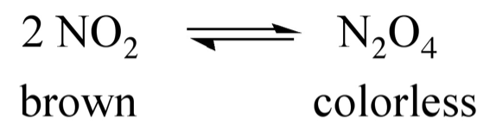

1. You would have been shown a gas tube (a sealed container) with this system at equilibrium. How did you know the system was at equilibrium?

____________________________________________________________________________________

____________________________________________________________________________________

____________________________________________________________________________________

1. What does it mean to say that the system is at equilibrium?

____________________________________________________________________________________

____________________________________________________________________________________

____________________________________________________________________________________

1. Write the equilibrium law expression for this equilibrium system.

|  |
| --- |
|  |

1. You may notice the colour of the gaseous mixture (when at equilibrium at room temperature) is only very pale brown. What does this observation imply about the value of the equilibrium constant for this system?

____________________________________________________________________________________

____________________________________________________________________________________

____________________________________________________________________________________

1. The system below is known to have a positive ∆H. Does this mean the reaction is endothermic or exothermic?

____________________________________________________________________________________

1. In one of the demonstrations for the mixture it was observed that as the temperature of the system is changed the colour of the system at equilibrium also changes. See the image below. (The higher the temperature the darker the equilibrium mixture is). Use Le Chateliers principle to justify this observation.

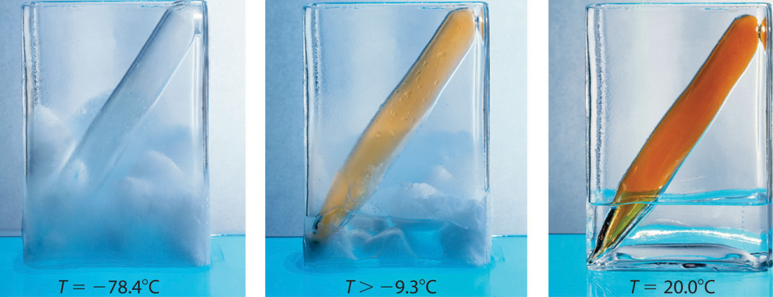

____________________________________________________________________________________

____________________________________________________________________________________

____________________________________________________________________________________

____________________________________________________________________________________

____________________________________________________________________________________

____________________________________________________________________________________

____________________________________________________________________________________

____________________________________________________________________________________

____________________________________________________________________________________

____________________________________________________________________________________

1. Does the value of K increase/decrease/ or not change at all for the three equilibrium systems above?

____________________________________________________________________________________

In the other demonstration your teacher compressed the gaseous mixture. (see image below).

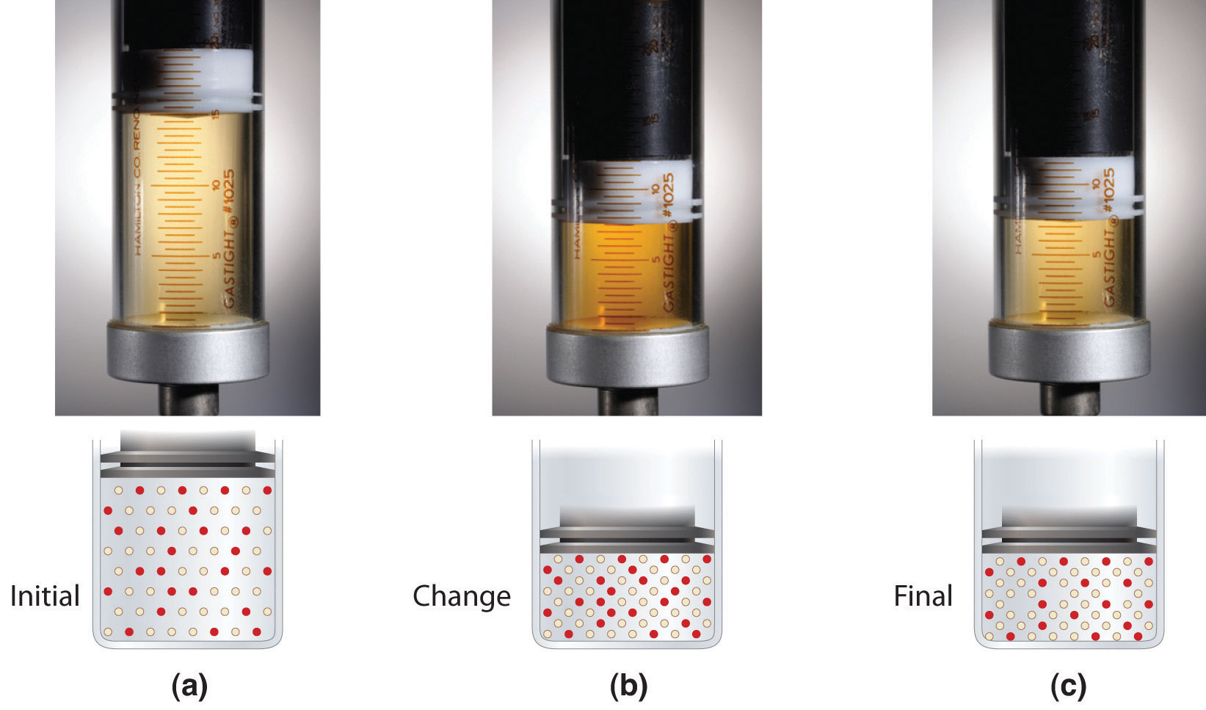

1. Initially the system was at equilibrium and appeared a very pale brown colour (see (a) on the image above). When the container was compressed (volume decreases/overall pressure increases) the colour became instantly darker brown (see (b) on the image above). Can you explain this initial observation.

____________________________________________________________________________________

____________________________________________________________________________________

____________________________________________________________________________________

1. Then after the initial darkening (due to compression – at time (b) on the image above) it can observed that the colour then fades again to pale brown (see (c) on the image above). Can you show how Le Chatelier’s principle can be used to predict this observation?

____________________________________________________________________________________

____________________________________________________________________________________

____________________________________________________________________________________

____________________________________________________________________________________

____________________________________________________________________________________

____________________________________________________________________________________

1. Consider the initial equilibrium system at time (a) and the new equilibrium established under higher pressure/lower volume at time (c). The system at time (c) is a little bit darker than the initial equilibrium mixture at time (a). Why?

____________________________________________________________________________________

____________________________________________________________________________________

____________________________________________________________________________________

1. Consider the initial equilibrium system at time (a) and the new equilibrium established under higher pressure/lower volume at time (c). Which has the higher K value. (careful!)

____________________________________________________________________________________

____________________________________________________________________________________

____________________________________________________________________________________

**DEMONSTRATION 2**

Today your teacher showed you a demonstration for the following system. A mixture of two substances a colourless molecules that we will refer to as MBred and a blue coloured moleculecalled MBox All questions below refer to this system.

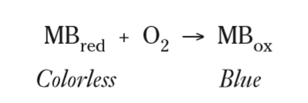

In the demonstration the mixture (which initially appeared colourless) is shaken and eventually turns blue.

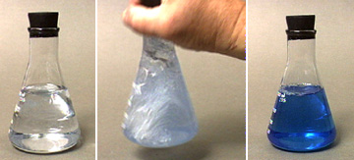

**A B C**

1. Justify that at time ‘A’ the system is at equilibrium.

____________________________________________________________________________________

____________________________________________________________________________________

____________________________________________________________________________________

1. Note the colour of the system at equilibrium at time ‘A.’ What could you conclude about the position of equilibrium? (is it towards the left or the right?). Justify your answer.

____________________________________________________________________________________

____________________________________________________________________________________

____________________________________________________________________________________

1. Upon shaking the bottled the equilibrium shifted and the solution turned blue (see picture on previous page). Can you show how Le Chatelier’s principle can be used to predict this observation?

____________________________________________________________________________________

____________________________________________________________________________________

____________________________________________________________________________________

____________________________________________________________________________________

____________________________________________________________________________________

____________________________________________________________________________________

____________________________________________________________________________________

1. What is the purpose of using a ⇋ in the equation for this equilibrium system? What does this imply about the reaction(s)?

____________________________________________________________________________________

____________________________________________________________________________________

____________________________________________________________________________________

____________________________________________________________________________________

**DEMONSTRATION 3**

Today your teacher showed you a demonstration for the following system. A mixture of a weak acid and its conjugate base. The equation below represents this system.

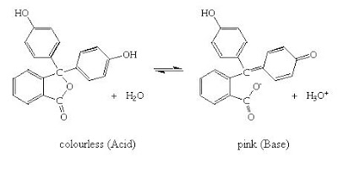

1. When sodium hydroxide (base) was added to the system above the colour of the solution changed from colourless to pink.
   * 1. Show how Le Chatelier’s principle can be used to predict this observation.

_______________________________________________________________________

_______________________________________________________________________

_______________________________________________________________________

_______________________________________________________________________

_______________________________________________________________________

_______________________________________________________________________

* + 1. Use collision theory to **explain** this observation.

_______________________________________________________________________

_______________________________________________________________________

_______________________________________________________________________

_______________________________________________________________________

_______________________________________________________________________

_______________________________________________________________________

1. When sulfuric (acid) was added to the system above the colour of the solution changed back from pink to colourless.



* + 1. Show how Le Chatelier’s principle can be used to predict this observation.

_______________________________________________________________________

_______________________________________________________________________

_______________________________________________________________________

_______________________________________________________________________

_______________________________________________________________________

_______________________________________________________________________

* + 1. Use collision theory to **explain** this observation.

_______________________________________________________________________

_______________________________________________________________________

_______________________________________________________________________

_______________________________________________________________________

_______________________________________________________________________

_______________________________________________________________________

**DEMONSTRATION 4**

In this demonstration an aqueous solution of yellow potassium chromate contains yellow chromate ions in equilibrium with a very small concentration of orange dichromate ions. The position of equilibrium is determined by not only the concentrations of each of these ions, but also by the acidity (i.e., the [H+] ions) of the solution.

The equation for this equilibrium is:

2CrO42−(aq)  + 2H+(aq) ⇋ Cr2O72−(aq) + H2O(l)

Recall:

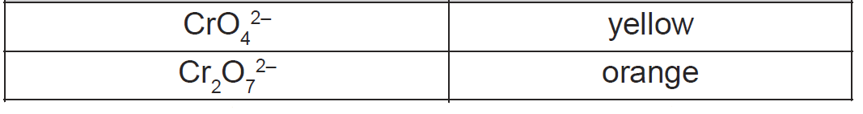

1. Write the equilibrium law expression for the equilibrium system above.

|  |
| --- |
|  |

1. Given the system above initially appears yellow under the conditions. What does this imply about the magnitude of the equilibrium constant? Explain your answer.

____________________________________________________________________________________

____________________________________________________________________________________

____________________________________________________________________________________

____________________________________________________________________________________

1. In the first part of this demonstration about 2 mL of dilute hydrochloric acid solution was added to about 5 mL of the equilibrium mixture in a test tube. The colour changed from yellow to orange. Use collision theory to explain this observation.

____________________________________________________________________________________

____________________________________________________________________________________

____________________________________________________________________________________

____________________________________________________________________________________

____________________________________________________________________________________

____________________________________________________________________________________

____________________________________________________________________________________

1. The change above result in the establishing of a new equilibrium. Specifically the position of equilibrium shifted right. Did the K value increase in magnitude? Why/Why not?

____________________________________________________________________________________

____________________________________________________________________________________

____________________________________________________________________________________

____________________________________________________________________________________

1. In the second part of this demonstration about 2 mL of dilute NaOH solution was added to the now orange equilibrium mixture. The colour changed back to yellow. Use collision theory to explain this observation.

____________________________________________________________________________________

____________________________________________________________________________________

____________________________________________________________________________________

____________________________________________________________________________________

____________________________________________________________________________________

____________________________________________________________________________________

____________________________________________________________________________________

1. In another demonstration another mixture of CrO42−(aq ­andCr2O72−(aq) is used. This time the system is orange initially. The system is then diluted by the addition of a large amount of water. Upon diluting the colour changed from orange to yellow. Show how Le Chatelier’s principle can be used to predict this observation. (the equation for the system has been provided again for you)

2CrO42−(aq)  + 2H+(aq) ⇋ Cr2O72−(aq) + H2O(l)

____________________________________________________________________________________

____________________________________________________________________________________

____________________________________________________________________________________

____________________________________________________________________________________

____________________________________________________________________________________

____________________________________________________________________________________

____________________________________________________________________________________

**DEMONSTRATION 5**

The reaction between Fe3+ ions and SCN− ions is a common equilibrium system used to study Le Chatelier’s Principle.The formation of the iron(III) thiocyano complex ion occurs almost instantaneously, the net ionic equation for the equilibrium system being as follows

**Heat + Fe3+(aq)  + SCN−(aq) ⇋ [FeSCN]2+(aq)**

**(BLOOD RED)**

Initially your teacher added 2 mL of 0.1 molL-1 Fe3+ ions (FeC*l*3(aq)) to 2 mL of 0.1 molL−1 solution of SCN− ions (KSCN(aq)) in a beaker. This was then diluted with distilled water to about 40 mL. The resulting equilibrium is a pale brown colour. Your teacher then numbers 7 test tubes 1 to 7. Add about 5 - 8mLs of the solution made above to the numbered test tubes

By referring to the table below, predict what you will observe when the following steps for each test 1 -7 listed in the table below are carried out. Make sure your answer compares the colour each time with the standard.

|  |  |  |
| --- | --- | --- |
| Solution number | Test | Predicted Observations |
| 1 | Put aside as the standard | No observable changes here. The solution remains pale brown. |
| 2 | Add 2 mL of SCN−(aq) solution (KSCN(aq)) |  |
| 3 | Add solid FeC*l*3(aq) |  |
| 4 | Add 2 mL of NaF(aq)  (Note: adding NaF results in the formation of a compound FeF2+) |  |
| 5 | Add 2 mL of AgNO3(aq)  *(note this results in the formation of a white ppt AgSCN)* |  |
| 6 | Warming the solution (increasing the temperature) |  |
| 7 | Diluting the mixture |  |

1. Explain why heating it caused the equilibrium mixture to change colour?

____________________________________________________________________________________

____________________________________________________________________________________

____________________________________________________________________________________

____________________________________________________________________________________

____________________________________________________________________________________

____________________________________________________________________________________

____________________________________________________________________________________

____________________________________________________________________________________

1. Use collision theory to explain how adding AgNO3(aq) caused the observation you predicted.

____________________________________________________________________________________

____________________________________________________________________________________

____________________________________________________________________________________

____________________________________________________________________________________

____________________________________________________________________________________

____________________________________________________________________________________

____________________________________________________________________________________

____________________________________________________________________________________

1. Why did the addition of solid FeCl3 impact this equilibrium system? I thought solids did not effect the position of equilibrium.

____________________________________________________________________________________

____________________________________________________________________________________

____________________________________________________________________________________

____________________________________________________________________________________

____________________________________________________________________________________

____________________________________________________________________________________

____________________________________________________________________________________

**DEMONSTRATION 6**

Iodine (*I*2) is dark coloured solid which sublimes on heating (meaning it bypasses the liquid state) to form a violet coloured gas.

The equation for this equilibrium is:

***I*2(s)  ⇋ *I*2(g)**

Below is a table that compares the colour each time with the standard which is the sealed tube at room temperature.

|  |  |  |
| --- | --- | --- |
| Test | Conditions | Observations |
| 1 | Room temperature | Pale violet colour observed with a small mass of solid iodine remaining at the bottom of the flask. |
| 2 | Hot temperature  (hot water) | Intense violet colour observed with a few grains of solid iodine remaining at the bottom of the flask. |
| 3 | Cold temperature  (ice) | Pale colour almost completely disappears. Mass of solid Iodine appears much greater than in the hot temperature system. |

Use Le Chatelier’s principle and your understanding of energy changes to justify the observations made in the table above.

____________________________________________________________________________________

____________________________________________________________________________________

____________________________________________________________________________________

____________________________________________________________________________________

____________________________________________________________________________________

____________________________________________________________________________________

____________________________________________________________________________________

____________________________________________________________________________________

**EXPERIMENT 1**

When solid cobalt(II) chloride is dissolved in water, the cobalt(II) ions become ‘hydrated’. This means that six water molecules become electrostatically attracted to each cobalt ion. This occurs because the water is polar and the more negative ends of the water molecules are attracted to the positive charge on the cobalt(II) ion. This gives the cobalt(II) ion its characteristically pink colour.

CoC*l*2(s)  + 6H2O (l) 🡪 Co(H2O)62+(aq) + 2C*l*−(aq)

(PINK)

If the water molecules are removed from the ion and replaced with chloride ions, the colour changes from pink to blue. The equilibrium equation for a system involving hydrated cobalt(II) ions is thus:

Co(H2O)62+(aq) + 4C*l*−(aq)  ⇋ CoC*l*42−(aq) + 6H2O(l)

(PINK) (BLUE)

In this series of demonstrations we effectively imposed some changes on the following equilibrium system.

Co(H2O)62+(aq) + 4C*l*−(aq)  ⇋ CoC*l*42−(aq) + 6H2O(l)

(PINK) (BLUE)

|  |
| --- |
| CAUTION  Concentrated hydrochloric acid is very corrosive and must be handled with extreme care. |

SET UP FOR TEST 1 and TEST 2

Place a pea sized amount of **CoC*l*2.6H2O (s)** in a test tube and dissolve in 1-2 mL of deionised water. This step results in the formation of Co(H2O)62+(aq)

**TEST 1: Add about 5 mL of concentrated hydrochloric acid solution to about 1 mL of cobalt(II) chloride in a test tube.**

Use Le Chateliers principle to **predict** what you may observe.

_______________________________________________________________________________________

_______________________________________________________________________________________

_______________________________________________________________________________________

_______________________________________________________________________________________

Now record your observations: ______________________________________________________________

_______________________________________________________________________________________

_______________________________________________________________________________________

**TEST 2: Add about 2 - 3mL of silver nitrate solution (AgNO3) to the original solution resulting from TEST 1.**

Now record your observations: ______________________________________________________________

_______________________________________________________________________________________

_______________________________________________________________________________________

Use Collision theory to **explain** your observations.

_______________________________________________________________________________________

_______________________________________________________________________________________

_______________________________________________________________________________________

_______________________________________________________________________________________

SET UP FOR TEST 3 and TEST 4

Place about a 2 gram amount of **CoC*l*2.6H2O (s)** in a test tube and dissolve in 5 mL of deionised water. This step results in the formation of Co(H2O)62+(aq). **Divide this solution between 2 test tubes.**

To BOTH of these test tubes, add dropwise concentrated hydrochloric acid solution until a definite colour change occurs. This establishes the following equilibrium.

Co(H2O)62+(aq) + 4C*l*−(aq)  ⇋ CoC*l*42−(aq) + 6H2O(l)

(PINK) (BLUE)

**TEST 3: Heat the first of the test tubes almost to boiling.**

Now record your observations: ______________________________________________________________

_______________________________________________________________________________________

_______________________________________________________________________________________

Use Le Chateliers principle tohelp you decide if the equilibrium system above is exothermic or endothermic.

_______________________________________________________________________________________

_______________________________________________________________________________________

_______________________________________________________________________________________

_______________________________________________________________________________________

**TEST 4: Dilute the second of the test tubes by slowly adding water.**

Use Le Chateliers principle to **predict** what you may observe.

_______________________________________________________________________________________

_______________________________________________________________________________________

_______________________________________________________________________________________

_______________________________________________________________________________________

Now record your observations: ______________________________________________________________

_______________________________________________________________________________________

_______________________________________________________________________________________